# Media Analysis - Will ChatGPT and AI have an impact on Saudi workforce productivity_ _ Arab News

## Short Summary

The article is about how ChatGPT and AI technologies have the potential to positively impact Saudi workforce productivity by automating mundane tasks, increasing efficiency, and allowing workers to focus on strategic activities.

## Summary

Here are 4 bullet points summarizing the text:  
  
• ChatGPT and other AI technologies have the potential to boost productivity in Saudi Arabia's workforce, but there is a concern that they may replace human labor with robots and software.  
• According to Raymond Khoury, senior partner at Arthur D. Little, nurturing an AI culture within organizations is essential for successfully implementing AI technologies and maximizing their benefits.  
• ChatGPT can have a positive impact on various aspects of Saudi Arabia's workforce, including recruitment, hiring, training, and development, as well as talent collaboration and knowledge management.  
• Khoury believes that AI will reshape the Kingdom's workforce in both the short and long term, increasing efficiency by automating mundane tasks and allowing workers to focus on strategic activities.

## Question 1

Based on the provided text, here s how the media frames the public discussion about ChatGPT The media frames the public discussion as follows * As an opportunity to boost productivity and economic development in Saudi Arabia * With concerns about replacing manpower with robots and software, but also highlighting the potential benefits of AI * Emphasizing the importance of nurturing a strong AI culture and developing skills that complement AI Some recurring metaphors used by the media include * ChatGPT as a wave of change in the global workforce * AI as a tool to boost productivity * Employees as needing to be nurtured with a strong AI culture to successfully embed AI into operations

## Question 2

**Perspectives and Aspects Widely Covered ** * The potential positive impact of AI on workforce productivity and economic development in Saudi Arabia. * The fear of job replacement due to AI and ChatGPT among employees. * The role of nurturing a strong AI culture and talent management in successfully embedding AI into operations. * The benefits of AI in providing tailor-made training programs, access to customized online courses, and fostering collaboration and communication amongst team members. * The potential impact of AI on various sectors such as healthcare, transportation, energy, finance, and retail. **Aspects Being Ignored ** * Potential negative consequences of AI implementation, such as job losses and displacement of workers. * The need for a comprehensive plan to address the skills gap and upskilling of employees. * The potential social and economic implications of widespread automation on Saudi society. * The role of government policies and regulations in supporting the adoption and development of AI technologies.

## Question 3

The article mentions that AI has created a wave of change in the global workforce that could benefit Saudi Arabia s personnel to boost economic development. It specifically discusses how ChatGPT and other AI technologies can impact the Saudi workforce, but it does not provide information on the role of other countries or regions in this context. Therefore, the answer is Not mentioned

## Question 4

The article concludes that with proper implementation and adoption, ChatGPT and AI can have a positive impact on Saudi workforce productivity, increasing efficiency, and opening opportunities for employees to upskill and reskill in a rapidly changing digital world.

## Sentiment

The sentiment is 4.0

## Entities

Saudi Arabias, Raymond Khoury, AI, Khoury, Embedding AI, Kingdoms, Arab News, Kasperskys, Kaspersky, Khourys, Arthur D. Little, Arthur D. Little

## Highlights

#7cc867: 42

#fb5b89: 18

#f9cd59: 8

#c885da: 8

## Wordcloud for #7cc867 Highlights

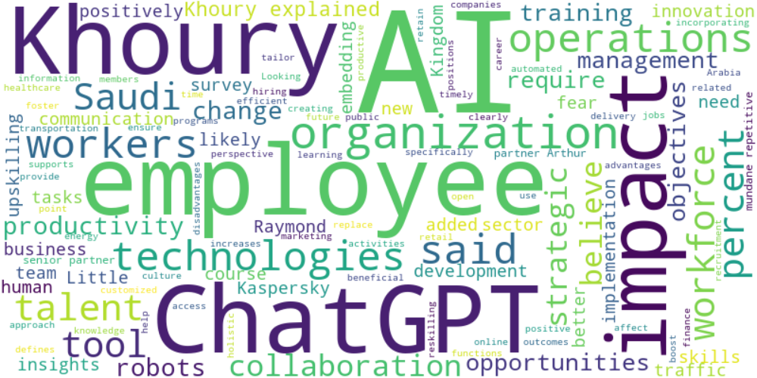

Top 10 words:

- AI: 35

- Khoury: 16

- ChatGPT: 12

- employees: 11

- impact: 9

- technologies: 6

- operations: 6

- said: 6

- workers: 6

- Saudi: 5

## Wordcloud for #fb5b89 Highlights

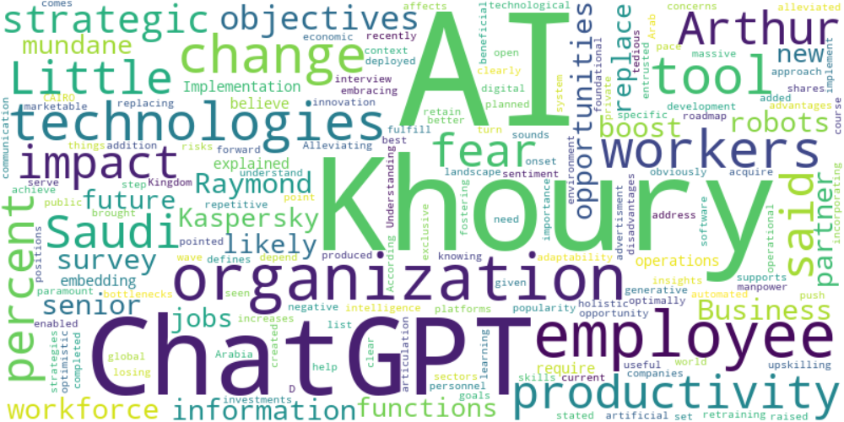

Top 10 words:

- AI: 14

- Khoury: 9

- ChatGPT: 6

- employees: 5

- technologies: 4

- workers: 4

- impact: 3

- Saudi: 3

- productivity: 3

- Arthur: 3

## Wordcloud for #f9cd59 Highlights

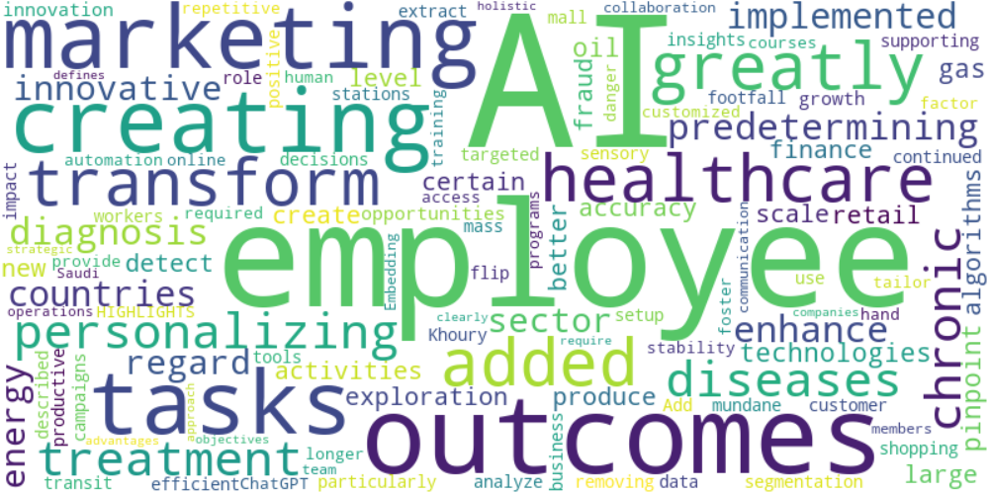

Top 10 words:

- AI: 7

- employees: 3

- outcomes: 2

- marketing: 2

- creating: 2

- tasks: 2

- added: 1

- greatly: 1

- transform: 1

- healthcare: 1

## Wordcloud for #c885da Highlights

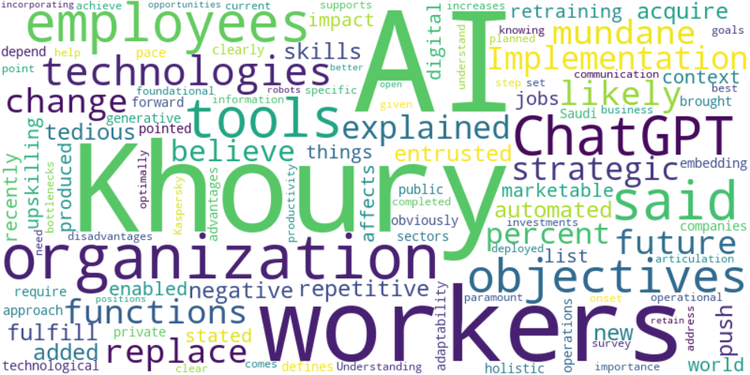

Top 10 words:

- AI: 8

- Khoury: 6

- workers: 4

- ChatGPT: 3

- said: 3

- tools: 3

- employees: 3

- objectives: 3

- organization: 3

- technologies: 3